Warm-Up: Reconstruction Amendments

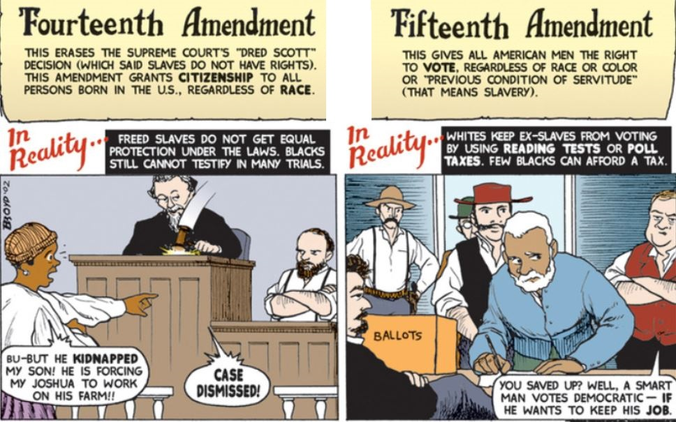
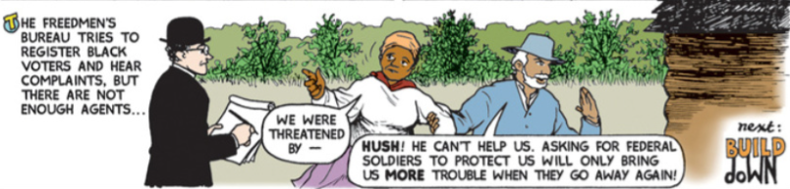

- What did the 14th Amendment grant to all persons born in the United States?

- What right did the 15th Amendment grant to former slaves?

- Why did former slaves need this right in order to build political power?

- How did the Freedmen’s Bureau attempt to assist former slaves?

